**Feasibility of Bio-calcification Technology for the Ecological Restoration**

(Sentence case, 13-pt. Times New Roman, Boldface, Left aligned)

Roshan Gunathilaka1*, Jeevan Mayooran2 and Elilarasi Kannan3 (Times New Roman, 11pt, Justified)

1 Department of Engineering Technology, Faculty of Technology, University of Jaffna, Kilinochchi, Sri Lanka.

2 Department of Biosystems Technology, Faculty of Technology, University of Jaffna, Kilinochchi, Sri Lanka.

3 Department of Interdisciplinary Studies, Faculty of Technology, University of Jaffna, Kilinochchi, Sri Lanka.

*\** Email address of the corresponding author (Times New Roman, 10pt, Left aligned)

**Keywords**: Keyword 1, Keyword 2, Keyword 3, Keyword 4, Keyword 5 (3 - 5 Keywords - Times New Roman, 11pt, Justified)

1 INTRODUCTION

The body of the extended abstract should be organized into sections; Introduction, Methodology/ Experimental Design, Results and Discussion, and Conclusions. Use 11 pt Times New Roman font throughout the extended abstract including text inside figures and tables. Single line spacing is mandatory. Try to avoid Underline or Bold within text.

The introduction should present a brief background of the study, research problem and the objectives. The methodology should be at minimal, sufficient to understand the research design [1]. You may include supporting figures, tables and images as necessary. Results should be combined with the discussion and be limited to discussing the main conclusions of the study. References should be listed in alphabetical order in a separate page in Harvard format [2].

All the Tables and Figures should be centered. Figures and images should be numbered (see Figure 1 and 2 for an example), and Figure legends should be placed under the figure or image; as for the tables, they should also be numbered (see Table 1 for an example), and the table header should be placed at the top [3].

2 MATERIALS AND METHODS

2.1 Heading

The methodology should be at minimal, sufficient to understand the research design [4]. You may include supporting figures, tables and images as necessary. This section should describe what was done to answer the research question/achieve research objectives, describe how it was done, justify the research design, and explain how the analytical tools/techniques were used.

Headings should be all left justified and numbered. You may use at most three levels of headings that correspond to chapters, sections and subsections. The first level headings for chapter titles should be in bold, justified, and upper-case font. The second level headings should be in bold, justified, and First Characters of Each Word are in Capital font. The third level headings should be in 11 pt and italics.

2.2 Tables and Figures

You may include supporting figures, tables and images as necessary. Figures or Tables should be possibly sized the whole width of a column, as shown in Figure 1 or Table 1 in the present example, or the whole width over two columns. You should locate them after and close to where they are first referenced. Tables should be auto-fit to single column or the whole width over two columns and no vertical lines or borders are needed.

You may use color figures and photographs in the extended abstract. However, please check that your color figures are legible when printed in monochrome (black and white). Please do not compress the Figures (images of 600 dpi resolution or more are preferable). Do not copy and paste the Figures from another text, and ensure that after printing, the images look good and readable. Do not use outer boundary. Figures should be auto-fit to single column or the whole width over two columns.

2.3 Equations

Equations and symbols should be typed in the equation editor. Number equations consecutively with equation numbers in parentheses, as in

$σ_{cr}=σ_{mu}+σ_{R}^{'}(V_{r})^{1.1}$ (1)

The equation number, enclosed in parentheses, is placed right justified. Refer the equation to “Eq. (1)” in the text. Symbols and notation should be defined when they first appear. Use one blank line before and after the equation. Equations should be auto-fit to single column.



**Figure 1:** Insert the figure caption here

3 RESULTS AND DISCUSSION

3.1 Proof reading

Results should be combined with the discussion and be limited to discussing the main conclusions of the study.

The papers should be fully in English (British English is preferred) and written in a way free from grammatical and spelling inaccuracies. The authors are encouraged to proof read carefully the paper prior to the submission.

**Table 1:** Insert the Table caption here

|  |  |  |
| --- | --- | --- |
| Heading 1 | Heading 2 | Heading 3 |
| Item | Item | Item |
| Item | Item | Item |
| Item | Item | Item |

3.2 Authorship

The corresponding author is responsible for ensuring that all authors have seen, approved and are fully conversant with the contents of the paper. All authors are responsible for the accuracy of the manuscript.

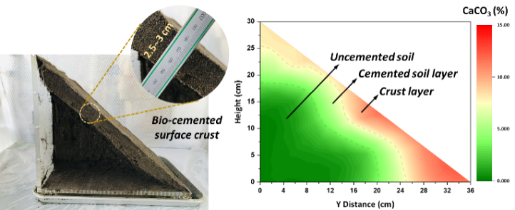

**Figure 2:** Insert the figure caption here

4 Conclusions

The body of the extended abstract should be organized into sections; Introduction, Methodology/Experimental Design, Results and Discussion, and Conclusion. Full paper must follow this pattern. This is important! Please note that this will be double-blind submission. The author’s identities will be removed before sending to reviewers. The authors will not know who the reviewers are.

# ACKNOWLEDGEMENT

Author/s must declare all sources of research funding in the extended abstract (where relevant).

# REFERENCES

[1]. DebMandal, M. and Mandal, S. (2011). Coconut: In health promotion and disease prevention, *Asian Pacific Journal of Tropical Medicine*, 4(3), pp. 241–247. doi: 10.1016/S1995-7645(11)60078-3.

[2]. Gummadi, V. P., Battu, G. R., Diyya M. S, Manda, K. (2016). A review on palmyra palm (*Borassus flabellifer*), *International Journal of Current Pharmaceutical Review and Research*, 8(2), pp. 17–20.

[3]. Jerry, A. (2018). A Comprehensive Review on the Medicinal Properties of *Borassus flabellifer*, *Journal of Academia and Industrial Research (JAIR)*, 7(7), pp. 93–97.

[4]. Marcus, S., Kim, P. and Lind, M. (2017). *Progress in Precision Agriculture Precision Agriculture: Technology and Economic Perspectives*. Available at: http://www.springer.com/series/13782.